**Quantitative Risk Analysis in Safety Engineering**

**Example Problems**

1. **Briefly explain the difference between *hazard* and *risk*. Provide an answer to identify and clarify the distinction between *hazard* and *risk*.**

Solution:

A **hazard** is an agent or condition with intrinsic potential to cause harm to something that is valued (person, property, environment, profit,…).

A **risk** is a measure of potential for a hazard to result in harm or damages based on the probability (or frequency) and consequence of an adverse event involving the hazard.

1. **(a) In a few words, state the three main questions to be answered by a risk assessment and state what is needed to answer each question (b) Give two example of barriers you may have to prevent an accident when you are driving to school in the morning.**

Solution:

**What can go wrong:** requires identification and characterization of hazards, including hazards due to Human and Organizational factors under the stated condition ranges and developing sequence of events from an initiation event and intermediate events and finally to an outcome event that can lead to upset or other adverse events.

**How Likely:** Likelihood or probability distribution of adverse scenario outcome event **Outcome consequences:** estimate outcome severities of adverse event scenario outcomes given the condition ranges.

b) Open ended question. Students should mention two measures that are in place to prevent an accident/mishap from occurring (e.g. car accident, barriers are seat belt, competency via licensing, abiding by the law etc.)

1. **The frequency of a scenario of events leading to accidental exposure of a toxic chemical is 3×10-4 per year. Such an accident can expose people to toxic air containing 10 μg/m3 of a carcinogen.**

**What is the individual annual risk (Rind) of such an accident to an exposed person?**

Solution:

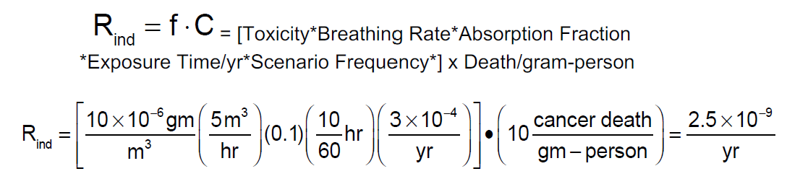

**What is the societal risk (Rsoc), i.e. the risk to the entire population? Involuntary risk criteria (i.e. the risk the general people living in a society are exposed to without knowledge or prior consent) is generally set to be 10-6/yr. Values of risk greater than this value is generally assumed to be unacceptable. Is this involuntary risk acceptable for the population?**

Solution:

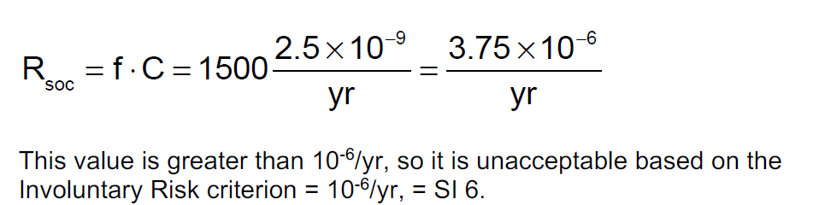

**What are the ‘odds’ of cancer death in the society?**

Solution:





**How long an exposure could lead to an individual annual risk of 10-6?**

Solution:

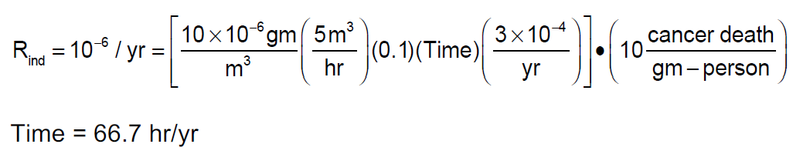

1. **The following table shows the data calculated in a risk study for assessing the risk of an LNG terminal:**

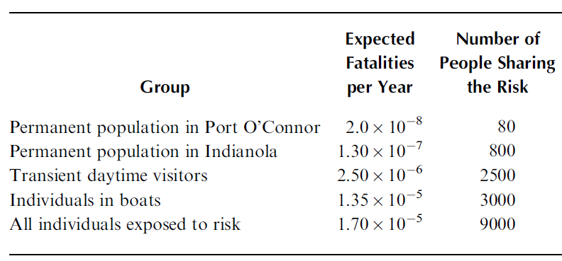

**The expected fatalities per year shown above show the risk to the various population. The number of people sharing the risk can be taken to be the number of fatalities (N) expected in case there is an accident at the LNG terminal.**

**In the table, add a column showing the risk per person per year.**

**Add another column showing the cumulative probability of exceeding a given number of fatalities and also the risk**

**Based on the data in this table, plot the risk profile in terms (annual frequency of exceeding the given number of fatalities versus number of fatalities (that is the so-called F-N curve or Farmer’s curve).**

**What is the frequency of exceeding 100 fatalities?**

Solution:

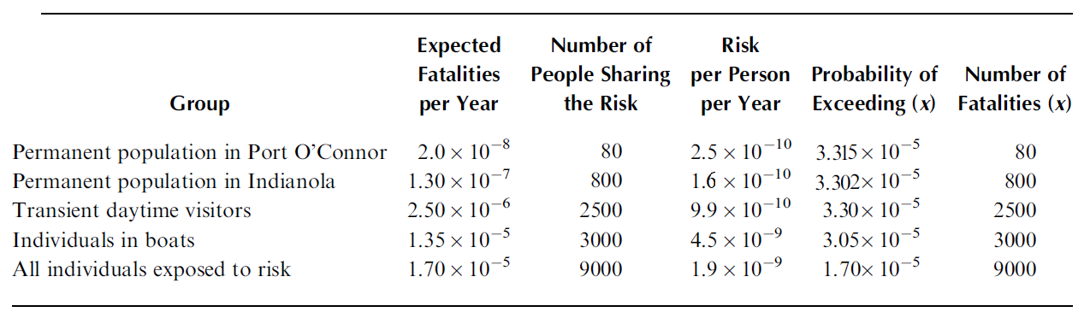



X axis: # of fatalities

Y axis: cumulative frequency per year

Frequency of exceeding 100 fatalities: By interpolation, frequency is 3.315×10-5/year

**5. a. What is the application of a risk matrix and an F-N curve?**

**b. Consider the example shown in the slides for the CNG Refueling station in Unit 3B. Identify 1 organizational factor that might influence a barrier in the refueling system.**

**c. Identify two scenarios that are affected by a common cause. Explain how.**

**d. Given a common cause affecting the scenarios, how will the cause effect the scenario’s position in the risk matrix?**

Solution:

F-N curve: Applied mostly for assessing Societal Risk. The main questions to be answered by a cumulative F-N profile: 1. What is the cumulative frequency or probability of outcome events with consequence levels equal to and greater than a given threshold value, c, to be reduced in probability of occurrence? 2. Does the cumulative occurrence frequency or probability decline at an acceptable rate, as the consequence level, C, increases from one fatality to multiple fatalities? For a risk averse manager, the greater the risk averseness, the more rapidly the frequency of occurrence must drop as the consequence level increases.

Risk Matrix: A risk matrix is a representation of scenario outcome risk values in two dimensions with probability of occurrence along Y (or X) and consequence magnitudes or severities along X (or Y). Risk matrices are used to show the rank of calculated risk levels such as acceptable (tolerable), conditionally acceptable, and unacceptable (intolerable) etc. It helps identify which scenarios impose the highest risk on a system and thereby allows prioritization of risk-reduction activities.

b. There can be various organizational influences: e.g. safety culture, frequency of training and evaluation of training (auditing), enforcement of safety practices, maintenance backlog, organization’s learning from incidents etc.

c. Different equipment failure might be influenced by a deeper cause related to the management. For example, if there is delayed or no regular inspection of critical equipment such as valves or filling lines etc. then both might fail together under certain circumstances. Both these failures are being influenced by a common organizational factor: inadequate inspection. Similarly, the maintenance program can also be such that equipment are not replaced or repair timely. In most cases, management’s conduct of operations plays a significant role in reducing incident probabilities.

d.

A common cause can make the risk level of a scenario move from a low risk zone to a higher risk zone as shown below:

